The Garage creates their own invoices in their software but we still record them in Adagio for receiving and for the sales reports.

You will get copies of invoices from the Garage and they need to be entered by the following Wednesday so that the sales report generated by payroll is up to date and accurate.

When you get the invoice you will be transferring the information into Adagio format. The customers name appears on the top left part of the invoice under Bill To:

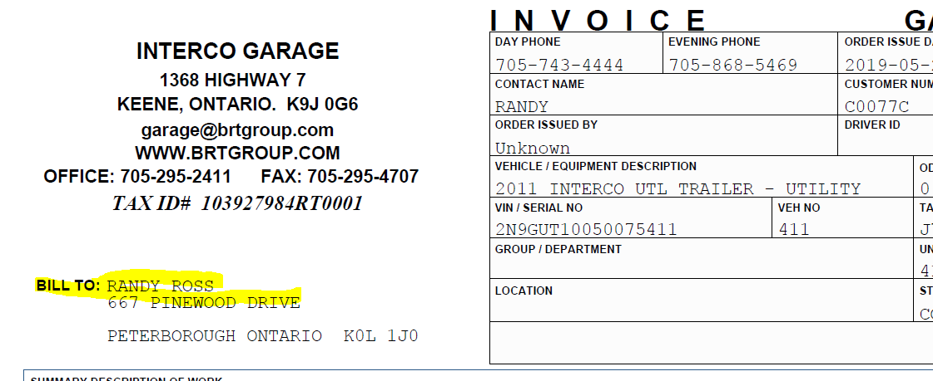

If this customer doesn’t exist in Adagio, create one using this information. If the Bill to is “Cash Customer” **bill it to CASH1 with the customer name as the PO#** found under Vehicle Number and/or VIN number.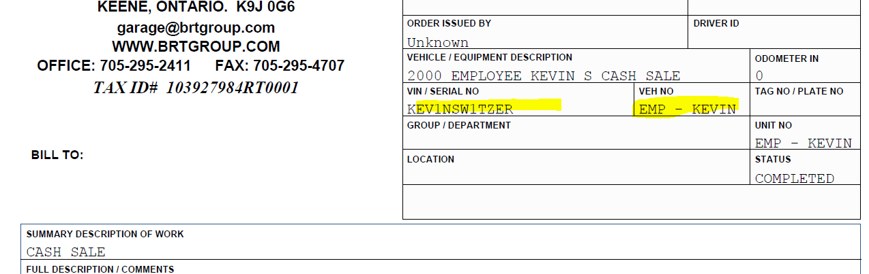

The date you use is the date Completed which is found on the bottim of the invoice to the left of the totals.

There are 2 items that can be used on a Garage invoice “GARAGELABOUR” and “GARAGESALE”

GARAGELABOUR is used for the labour hours billed on the invoice and you entered it in as the amount being the amount of hours and the unit price as the hourly rate listed on the Garage invoice.

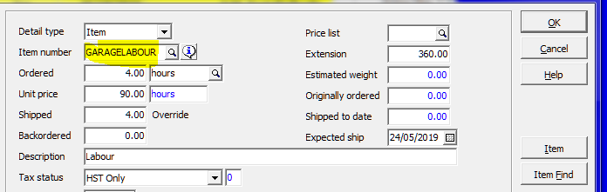

GARAGESALE is used for materials, the quantity is 1 and the unit price is the total parts/materials on the Garage invoice. The decription should be updated to say Parts or something that matches what is on the Garage invoice.

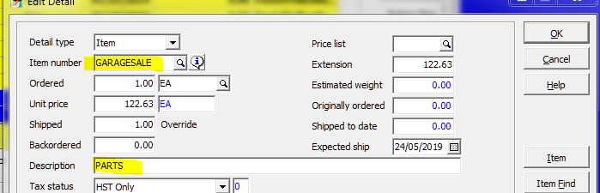

Under the Total tab:

Make sure the Garage invoice total and your total match and that both the actual ship date and invoice date are the same as the “date completed” on the Garage invoice.

When you complete the invoice the “Order Number” is GO-“the Garage invoice #” which is on the top left.

Example:

**Garage invoice# GAR-5733 would be Adagio Order # GO-5733**.

The Adagio invoice # is auto.